Name: ANAND VK Batch: B8 Task: 1)How to search and replace insensitive pattern in an opened file

2)How to search and replace the pattern only in 4th and 8th line

3)How to delete a characters where the cursor is pointing

Date: 19-01-2024

# How to search and replace insensitive pattern in an opened file?

# Ans) first we should place the cursor to the line which we want to replace by pressing ‘ESC nG’

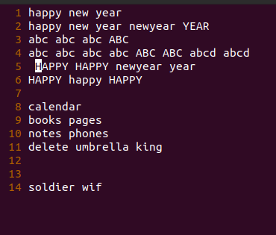

For replacing case insensitive pattern type ESC:set ic

Then type,

:s/search pattern/return pattern/g

For ex:

To replace abc with vk in 4th line

step1) press ESC & then type 4G to point the cursor in the 4th line.

Step2)press ESC:set ic

Step3)press ESC:s/abc/vk/g

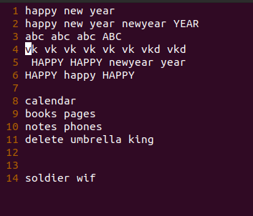

**2)How to search and replace the pattern only in 4th and 8th line ?**

Ans)

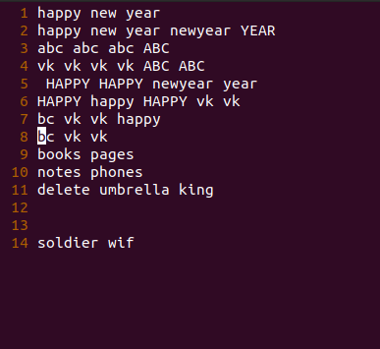

For replacing only in 4th and 8th line we press

ESC:4s/search pattern/return pattern/g | 8s/search pattern/return pattern/g

Forex: replacing ‘vk’with ‘abc’ only in 4th and 8th line

We type,

ESC:4s/vk/abc/g | 8s/vk/abc/g

As shown below

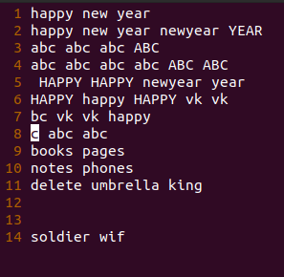

**3)How to delete a characters where the cursor is pointing?**

Ans) we press ‘ESC x’ for deleting characters

